Automating Employee Data in ServiceNow

Import data from data source
1.Steps to Create records in the Sheet
- Open google sheet.
- Name the fields as name, email, department manager and manager’s email.
- Enter some records.
- Save the sheet as: employee data.
- Download the file as .xlsx , .csv (or) .xml file.

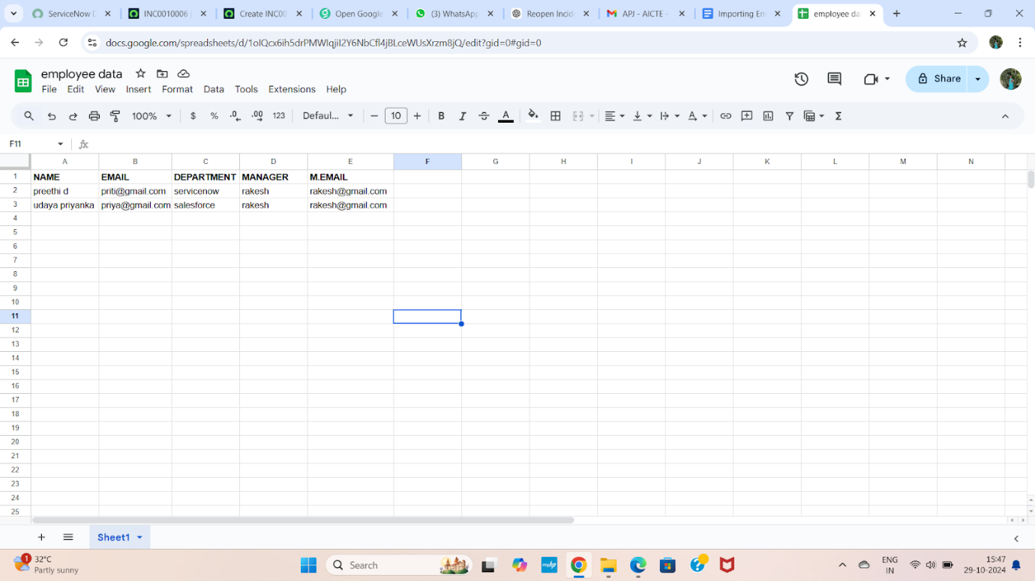

2.Steps to Import data
- Open service now.
- Click on All >> search for import sets
- Select load data under system import sets
- select create table
- Give the import set table name as: import employee
- Choose the file which we created in the XL sheet.

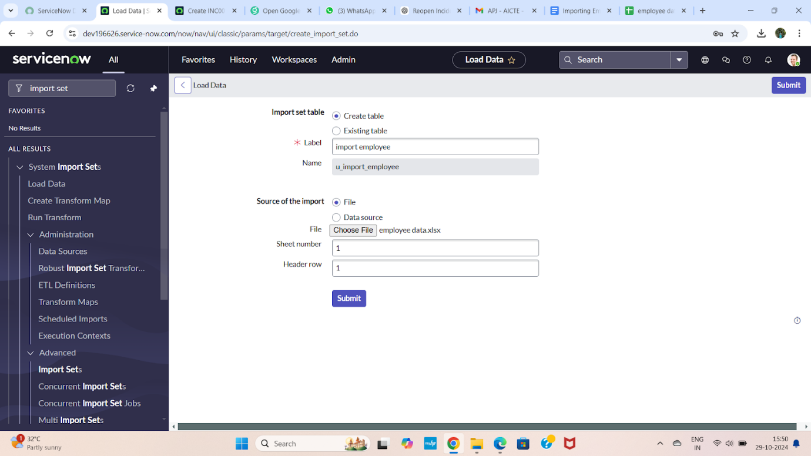

- The data is imported, click on personalized list
- Add fields to the form.
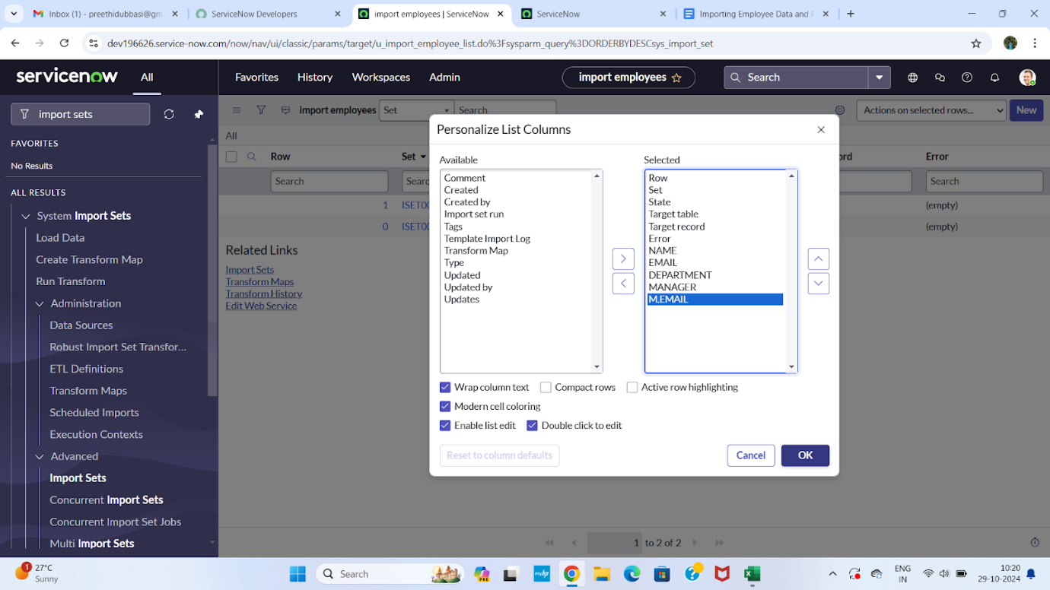
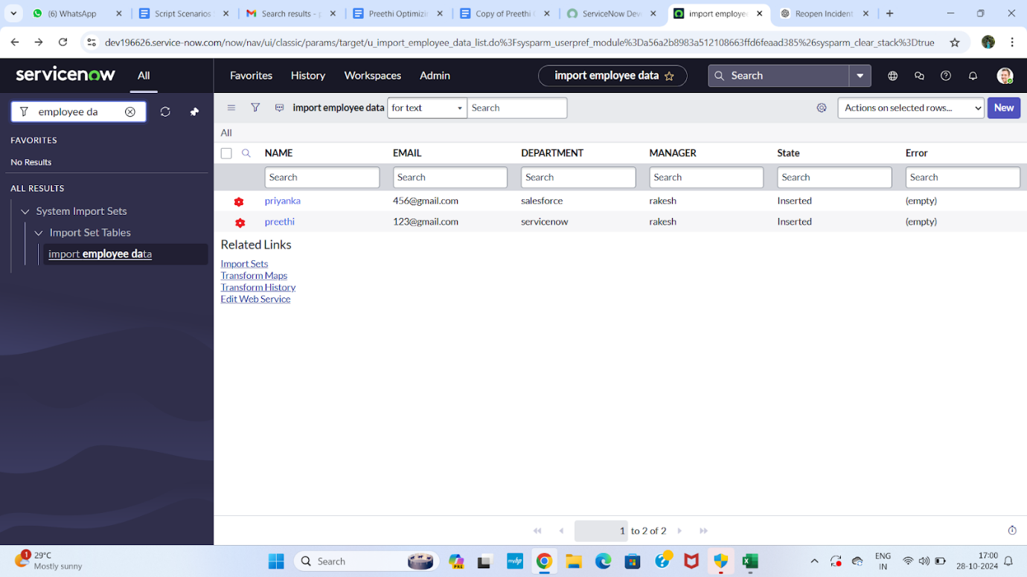

3.Steps to Create transform map
- Open service now.
- Click on All >> search for import set
- Select create transform map under import sets
- Click on new
- Fill the following details to create a new transform map
- Give name as: Employee data transform
- Select source table: import employee data
- Select target table: user[sys_ user]
- Save the form.

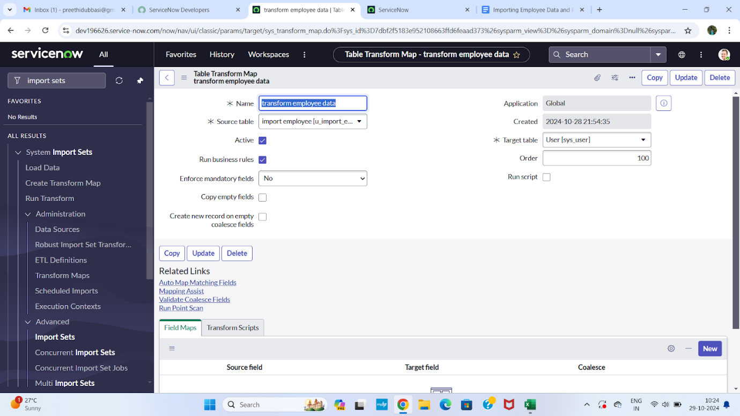

4.Steps to Match the fields using mapping assist
- Scrolled down the created transform map form
- Click on auto matching fields
- Then in the mapping fields some fields are matched
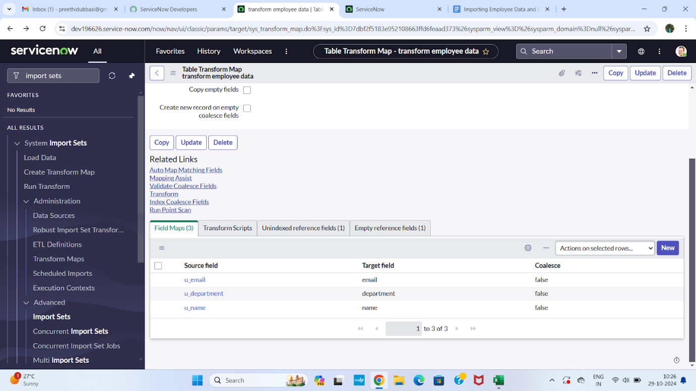
- Using mapping assist map the manager field.
- Select the fields which you are mapping in the staging table and target table.
- Select manager in source table and add.
- Select manager field in target table.
- Click on the save button.
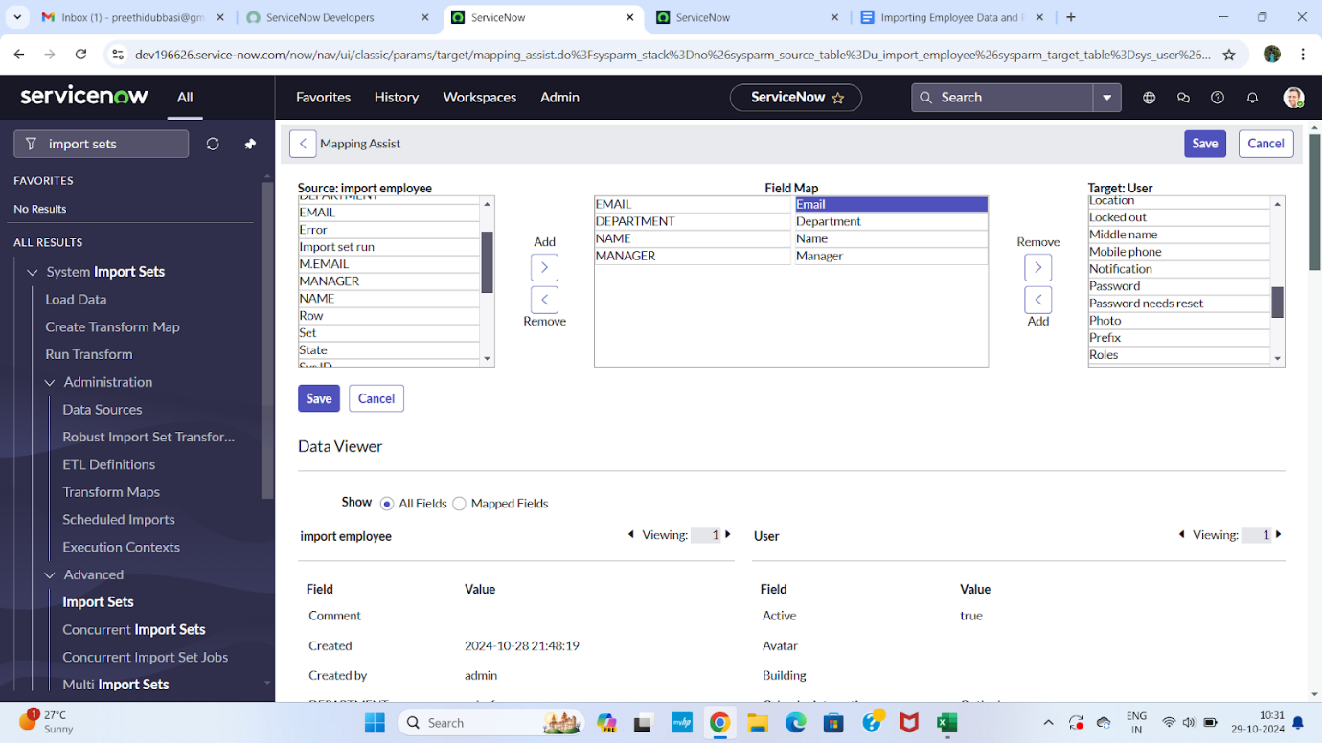
5.Steps to Transform the Data
- Click on transform in the related links.
- Click on transform.
- Data's transform state is completed.
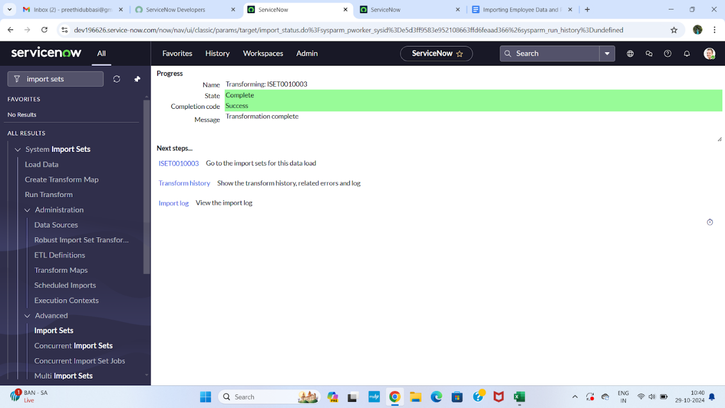
- Click on ISET0010003 under next steps
- Two rows are inserted.
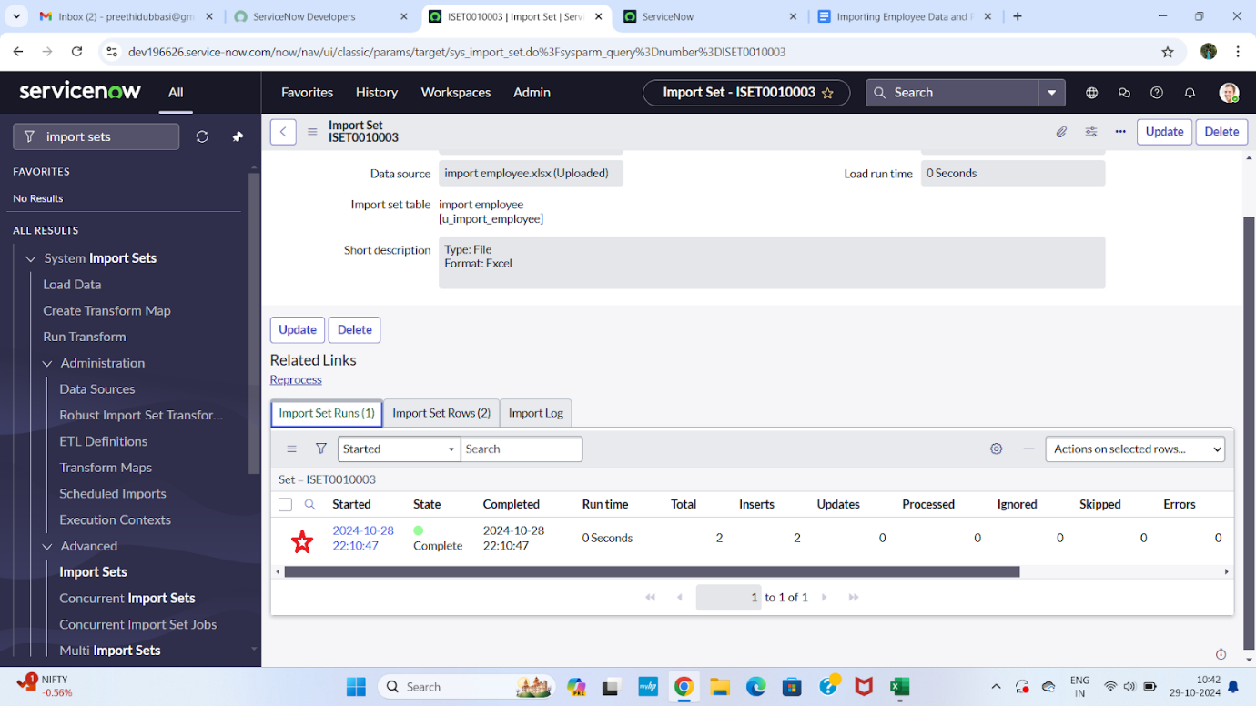
Dot walking
Display department to the assigned to user
- Open service now.
- Click on All >> incident
- Select create new under incidents
- There is no field like department in the form
- Email and manager fields are not visible
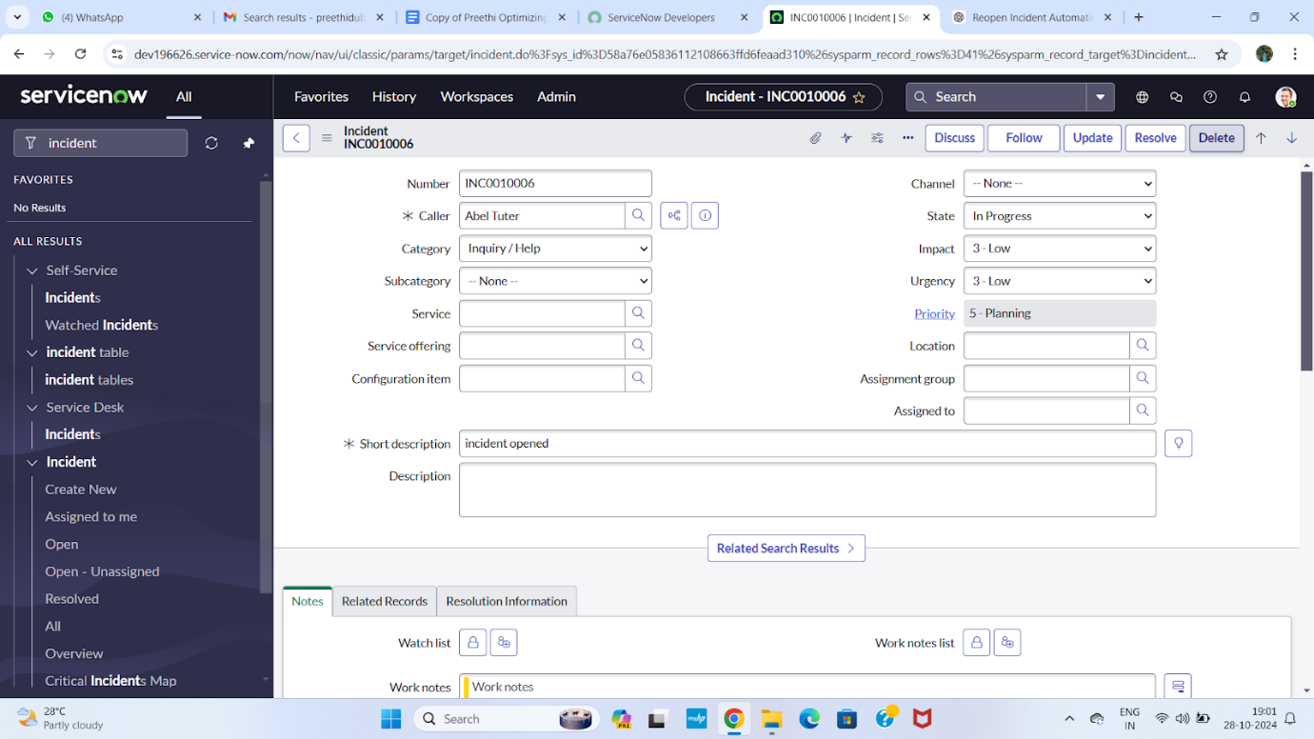
- By using dot walking retrieve the data without opening the record
- Click on context menu go to configure and select form layout
- Select assigned to department as mentioned below
- Click on save.
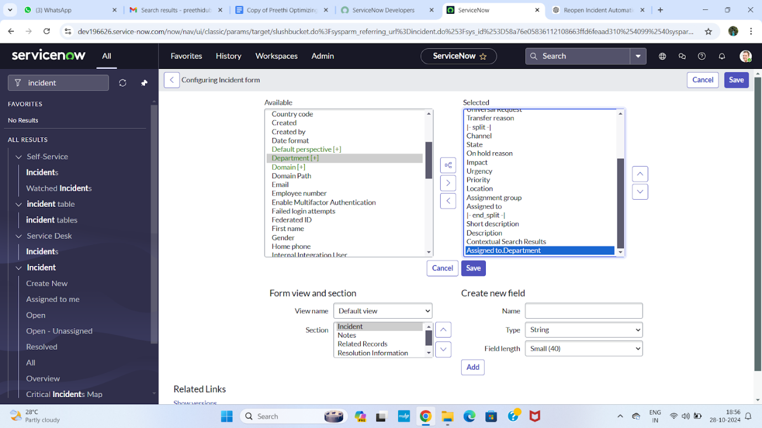
- Add another field assignment email.
- Also add assignment manager field
- Click on save.
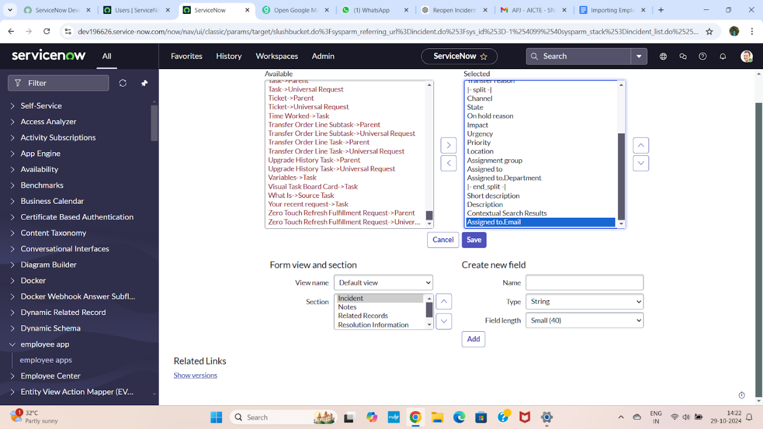
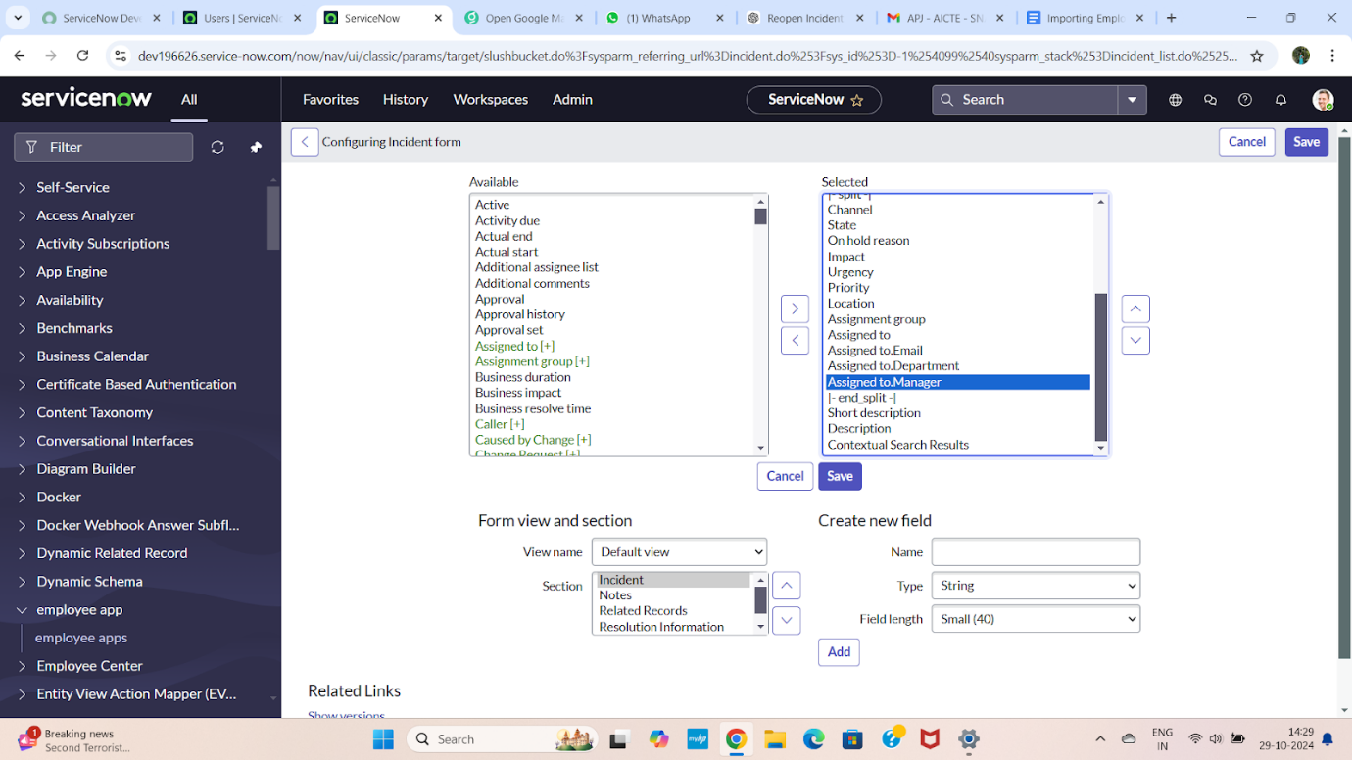
- Open an incident form
- Fill the mandatory fields and assigned to just imported user
- Then department and email field is automatically filled
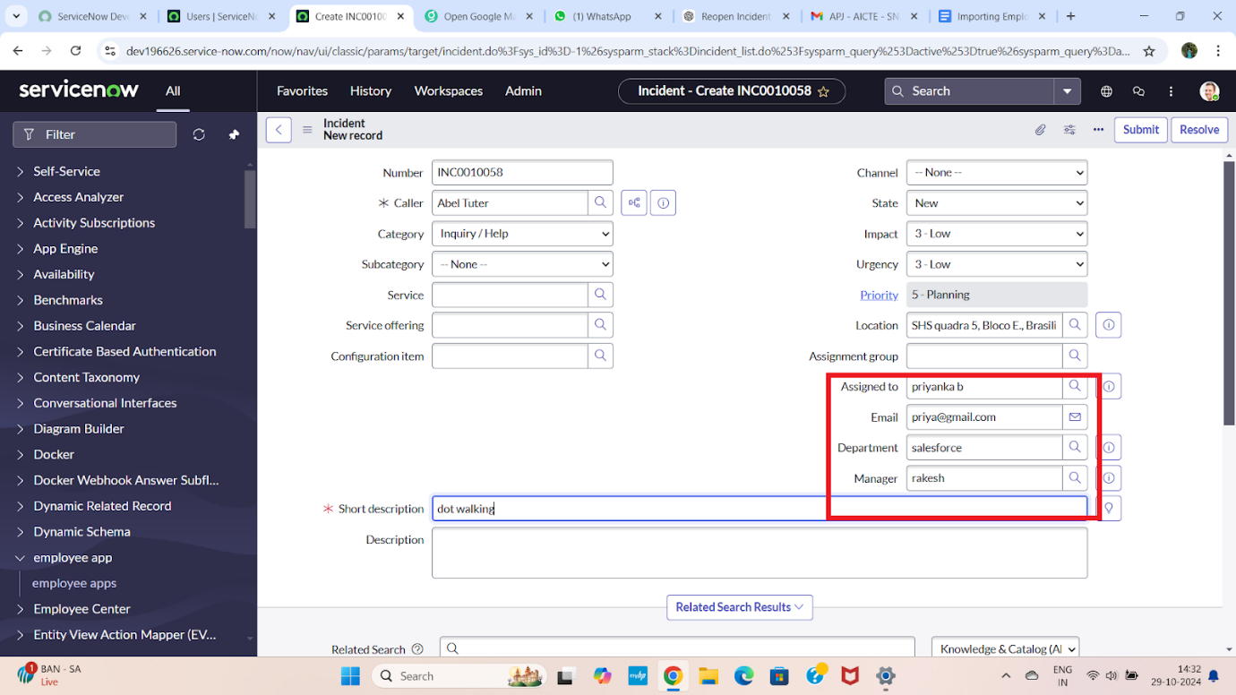

Dictionary override
Make the state to 3-moderate in incident
- Navigate to All → System Definition → Tables.
- Either:
- Use the existing Incident table (which extends Task), OR
- Create a new table (e.g., u_ incident _table) and set Extends Table = Task.
- Open the Incident (or extended) table record.
- Go to the Columns related list and open the Priority field. Notice the default value is inherited from the Task table (e.g., 4 – Low).
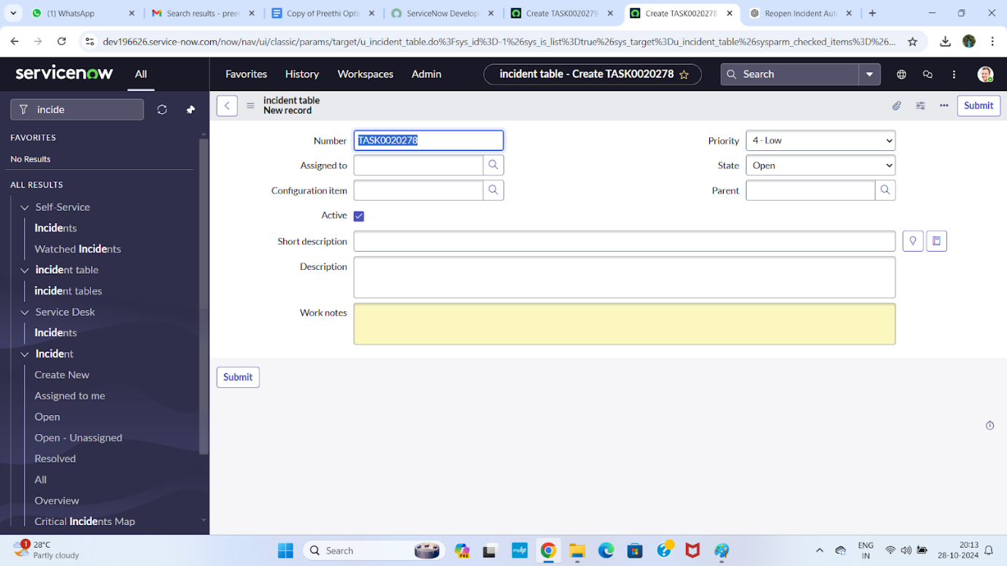

- Scroll down and locate the Dictionary Overrides related list.
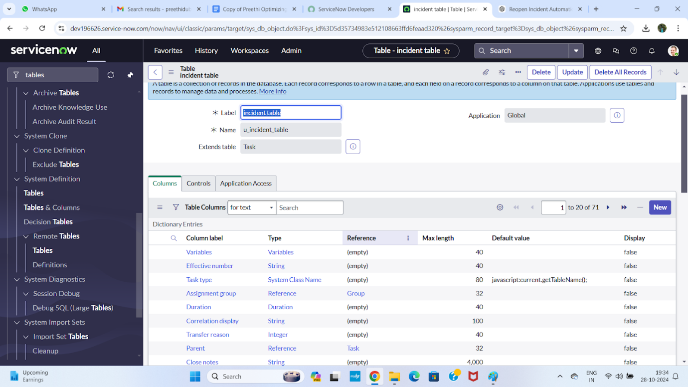

- Click New under Dictionary Overrides.
- Fill the following details:
- Table: Incident (or your extended table)
- Column name: Priority
- Check Override default value
- Set Default value = 3
- Click Submit.
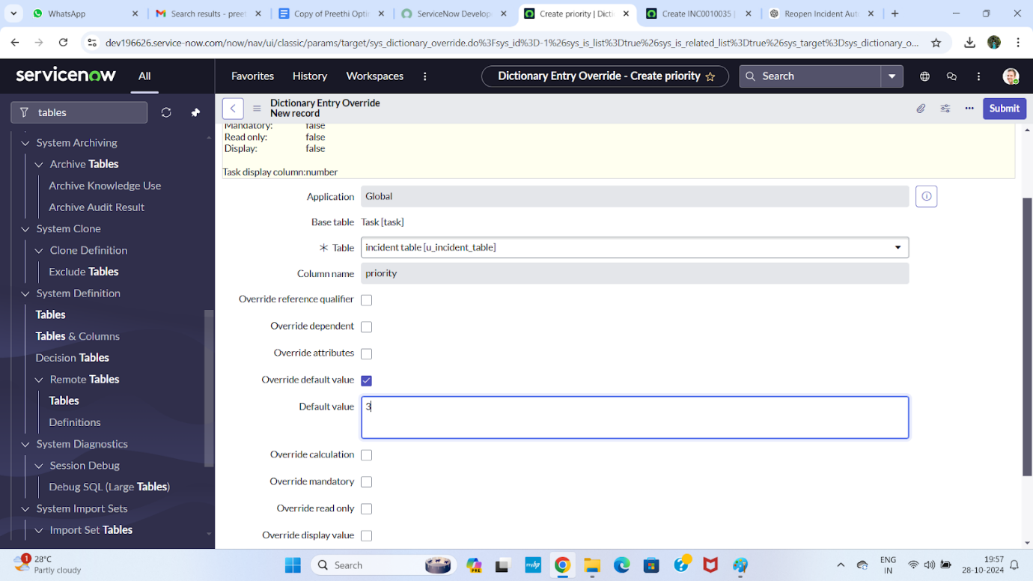
- Open a new Incident record and verify that the Priority now defaults to 3 – Moderate, while the Task table still retains its original default value.
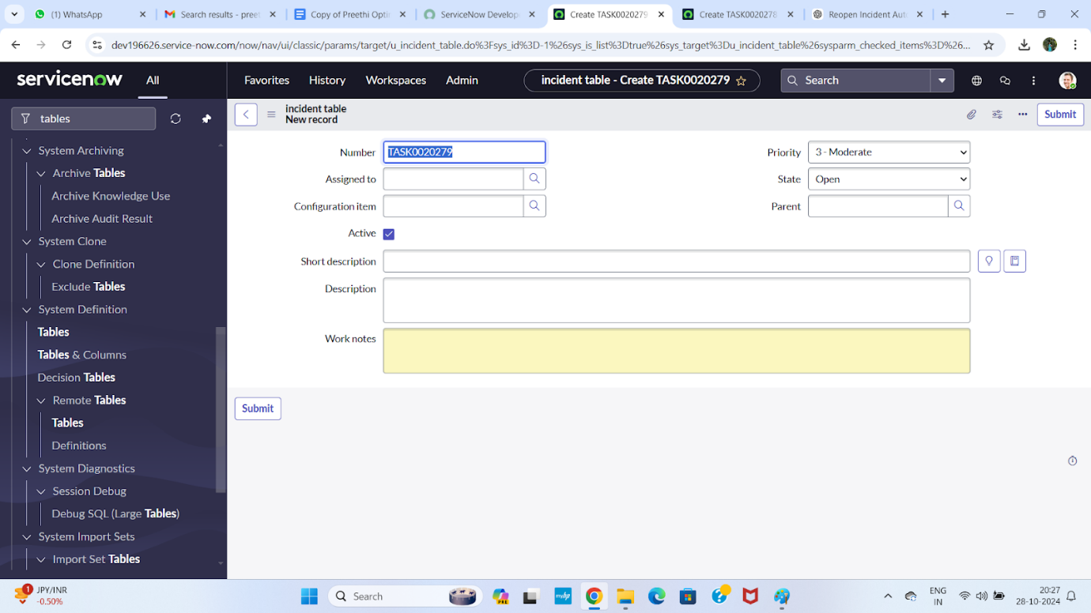

Conclusion
In this project, we enhanced incident management by integrating external employee data into ServiceNow through Import Sets and Transform Maps, eliminating manual data entry and ensuring accurate user records. By leveraging dot walking, we enabled real-time visibility of related information such as department and manager details directly on the Incident form without duplicating data.
Additionally, the use of Dictionary Override allowed us to customize the default Priority value specifically for the Incident table while preserving the inherited behaviour of the parent Task table. This ensured that incidents follow a priority structure aligned with business urgency without impacting other task-based processes.
Overall, the solution improves data accuracy, reduces administrative effort, and provides incident handlers with immediate access to critical contextual information. The combination of data integration, relational referencing, and table-level customization creates a more efficient, scalable, and structured incident resolution workflow within ServiceNow.

